MK Orbiter Procedures
Procedures Document
MK Data Factory
Produced By: | Acxiom Corporation
Document Version: | Version 1.3
Version Date: | July 1, 2005

Document Approvals
The signatures below confirm approval of this document.
Jim Shelton, MK Project Manager, Acxiom
Glenn Banfi, MK Business Analyst, Acxiom
Tim Steiger, Ascential DataStage Consultant, IBM
Kumar Cuddalore, Ascential DataStage Consultant, IBM
Craig Chapa, MK Technical Leader, Acxiom

Revision History
When you make a change to a document, you must add an entry to this Revision History table and you must manually type the Version Date on the front cover.

Revision Date | Revised By | Revision Description
06/14/2005 | Toby Drake | v 1.0 – Created first draft.
06/16/2005 | Toby Drake | v 1.1 – Inserted technical review modifications.
06/23/2005 | Toby Drake | v 1.2 – Tim Steiger / Kumar Cuddalore updates.
07/01/2005 | Toby Drake | v 1.3 – Final review session updates.

Contents

1. Purpose 4
2. Description 4
3. Associated Documents 5
4. Before You Begin 5
5. On-Screen Orbiter Navigation 6
6. Orbiter Templates 6
7. Creating a New Orbiter Job 7
8. Creating Submit Options 12
9. Creating a New Process 18
10. Job Tracking 22
10.1 Job Status 22
10.2 Job Log 24

Figures

Figure 1. On-Screen Navigation 6
Figure 2. Job Setup Screen 7
Figure 3. Open a Job Template 8
Figure 4. Job Specifications and Parameters 9
Figure 5. Job-Level Pre- and Post-Job Instructions 10
Figure 6. Submit Options 11
Figure 7. Configuration and Administration 12
Figure 8. Submit Options Templates 13
Figure 9. Notification Settings 14
Figure 10. File Arrival Settings 15
Figure 11. Cost Accounting Type 15
Figure 12. Engine-Level Pre- and Post-Job Instructions 16
Figure 13. Engine Parameters 16
Figure 14. Configuration File 17
Figure 15. Job Setup and Submission 18
Figure 16. Create Process 19
Figure 17. Submit Options Run-Time Edit 21
Figure 18. Job Tracking Tab 22
Figure 19. Job Status and Status History 23
Figure 20. Job Log Selection 24
Figure 21. Job Log Example 25

Purpose
The purpose of this document is to provide the information and procedures necessary to complete the following tasks for the MK project:
- Create a new Orbiter job
- Create Submit Options for a job or process
- Create a new Orbiter process
This document applies only to creating, modifying, and submitting Market Knowledge (MK) DataStage jobs using the Orbiter web-based interface. Information about Orbiter as it applies to other types of projects and job types can be found at the Orbiter web site: http://orbiter.corp.acxiom.net/index.html.
NOTE: This document provides information on a developing process. It may contain inaccurate or out-of-date information.

Description
Orbiter is a web interface for structuring jobs, processes, and flows for the Acxiom Technology Framework (the grid). Orbiter allows you to create basic transforms, structure jobs, and schedule processes. Orbiter is also used to submit these jobs and processes to the scheduling and resource management utility (called Nexus).
Many of the Orbiter features are not currently used for the MK project. Within the current MK project, Orbiter is used primarily as a wrapper for jobs built using Ascential DataStage.
Orbiter is also used to prepare the jobs to run in different operating environments. This is accomplished using submit options (parameters). Orbiter also provides tracking features for identifying and reporting when a job started, ended, completed, or failed.
Typically, you create your Orbiter job and then string multiple Orbiter jobs together to create an Orbiter process. Once these processes are created, you create or modify the submit options for the job or process, and then submit it to the grid.
This document will guide you through the most common Orbiter tasks you will need to complete on the MK project. For additional information about Orbiter, along with Help and other reference materials refer to the Orbiter web site: http://orbiter.corp.acxiom.net/index.html.
NOTE: Within Orbiter application, the term function is used to describe a stand-alone Orbiter job.

Associated Documents
This document is supplemental to Orbiter documents and other information contained at the Acxiom Orbiter web site: http://orbiter.corp.acxiom.net/index.html. Conceptual information and other Orbiter reference materials for the MK project are located on the following MK SharePoint site:
https://iriteams.infores.com/sites/regfactory/CODF%20Project%20Deliverables/Forms/AllItems.aspx?RootFolder=%2fsites%2fregfactory%2fCODF%20Project%20Deliverables%2fData%20Cleansing%20and%20Scrubbing%20Team%2fOrbiter&View=%7bE5CCF53C%2dD4C8%2d4A59%2dB071%2dDCF93BFA2D50%7d
If this is a printed version of the document, follow the SharePoint path below to find additional Orbiter reference materials:
MKG Home > Project Deliverables > Data Cleansing and Scrubbing Team > Orbiter

Before You Begin
To use the information contained in this document, you must have:
- A basic understanding of fundamental Orbiter concepts.
- An Acxiom corporate LAN account username and ID.
- Technical access to the Orbiter web-based client application. You access the Orbiter web-based client using your Acxiom LAN credentials. However, you have to be added to the list of approved Orbiter technical users. This requires that your project administrator create an Acxiom Security Access request for you (http://levelzero/Security_Request.asp).
- Access to the Nexus web-based client application.

On-Screen Orbiter Navigation
There are several menus, tabs, and buttons to aid in your navigation of Orbiter. There are other less obvious aids to navigation that you will need to use while you are working within the Orbiter application.
The back and forward buttons on your web browser are disabled while in the Orbiter application. You must use the information on the screen to navigate to other areas.
For instance, if you are working in a screen and need to go back to a previous screen, you will need to use bread-crumb navigation (as shown in Figure 1). And, if you need to save your work or complete another task-related activity, you will need to use the on-screen options menu.

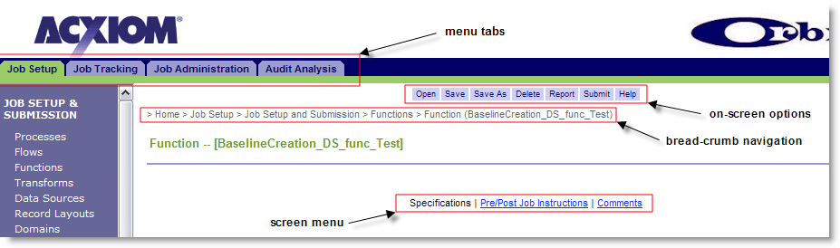
Figure 1. On-Screen Navigation

Orbiter Templates
When you first create a new Orbiter job, process, or submit options file, you will need to enter several parameters that are common among all jobs and processes that run in the different grid environments. To make this less time consuming, several templates are available that contain the basic environment and parameter information. These templates are located in each of the Orbiter file libraries.
NOTE: The filenames may change as the project is updated with new processes. Make sure to contact your project leader to determine the most recent templates available.
The following lists the templates you should use when building Orbiter jobs. The file name identifies the environment that corresponds to the template.
For example, Template_DS_func_Dev should be selected if you are creating a job for the development environment.
NOTE: The staging environment is a secondary testing environment. A specific submit options staging template file is used when submitting test jobs to this environment.
- Job templates:
Template_DS_func_Dev
Template_DS_func_Test
Template_DS_func_Prod
- Submit Option templates:
app_Template_Dev
app_Template_Stage
app_Template_Test
app_Template_Prod
- Pre and Post script templates:
ds_prejob.ksh
ds_postjob.ksh

Creating a New Orbiter Job
The following procedure provides the details necessary to structure a new Orbiter job. This procedure assumes you have met the necessary prerequisites described in Section 4.
- From the main Orbiter screen, click the Job Setup tab, and then click Job Setup and Submission.
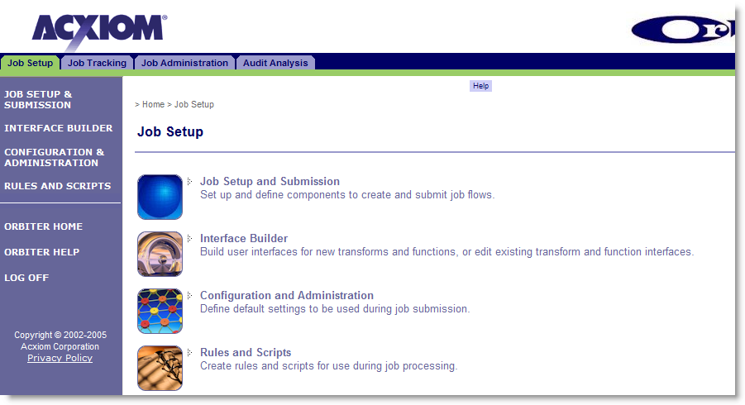
Figure 2. Job Setup Screen
- From the Job Setup and Submission screen, select Functions.
- If necessary, select IRI from the pull-down list of available libraries.
- Select an Orbiter job template from the list of available functions (see Figure 3) and click OK. Make sure to select an Orbiter job template that was created for the environment where your job will run (see Section 6).
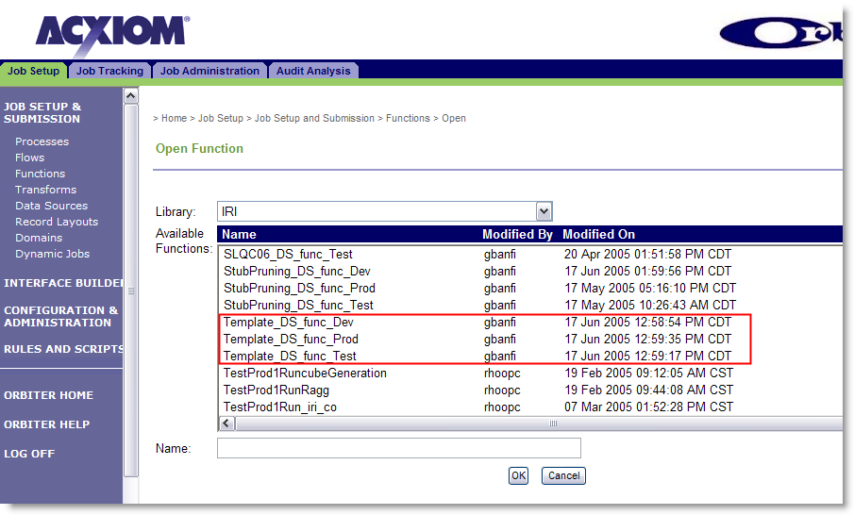
Figure 3. Open a Job Template
The environment types for each job template can be identified by the naming convention used. Do not modify any of the parameters for the template job. You are simply using this template as a base to create the new job.
- Click Save As and save the Orbiter template job with a new name. Use the standard naming convention: {module}_DS_func_{environment}.
- Click OK. The job specifications and parameters screen is displayed.
(see Figure 4)
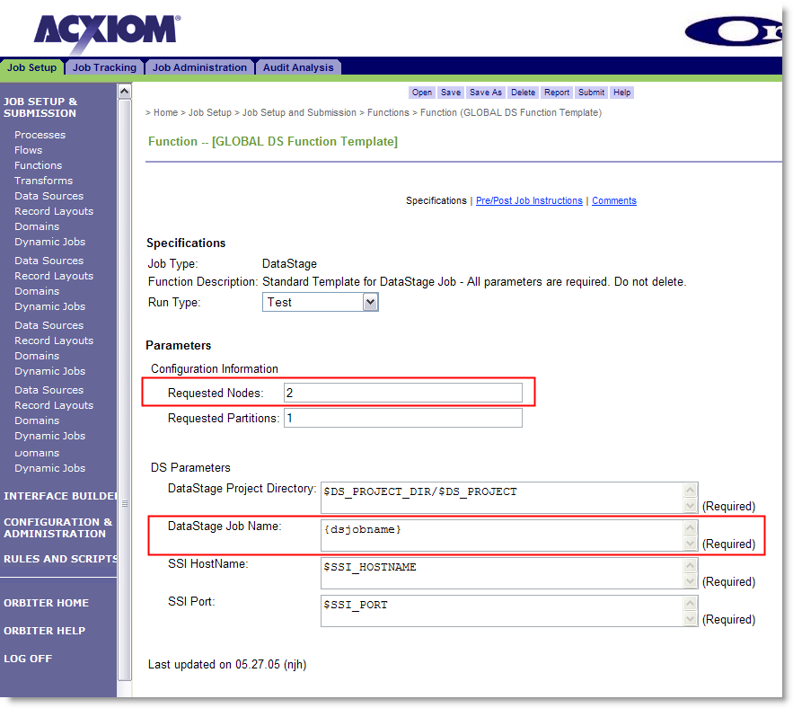
Figure 4. Job Specifications and Parameters
- Modify the following entries on the Specifications and Parameters screen.
Under Specifications, select the Run Type that corresponds to the environment where you will be submitting the job. Typically, when you first create an Orbiter job to run in the development or testing environment, you select Test. Later, after the job has been tested and is ready for production, you change the Run Type to Production.
Many of the values under Parameters (see Figure 4) are default values based on the environment where the job will run. Other values are dynamic parameters that are loaded at run-time, based on information you supply in Submit Options.
Under Parameters, modify the following information:
- Requested Nodes. This is the number of nodes requested to run the job. Generally, when you first create a job, you assign the job run on two (2) nodes. Then, while testing the performance of the job, you determine if more nodes are required. If more nodes are required, you can modify these parameters and increase the number of nodes.
NOTE: For the current MK project, the maximum number of nodes you should use is eight (8). (This maximum node number may be increased as needed for future releases.)
- Requested Partitions. This is the number of partitions requested for each node. For the MK project, the default value for this field is one (1) partition requested.
Under DS Parameters, enter the name of your new job in the DataStage Job Name field. Follow the standard naming convention used for other Orbiter jobs.
The DataStage Project Directory, SSI Hostname, and SSI Port parameters are dynamically loaded from the Submit Options created for the process or job.
- Click Pre/Post Job Instructions in the task menu.
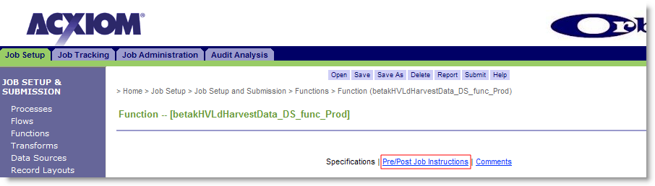
- Complete the Pre Job Instructions and Post Job Instructions fields. Typically, these fields contain a single command line that will launch a pre- or post-job script. Click Find to search available scripts in the script library.
A pre-job script loads job parameters that change dynamically for a group of DataStage jobs. A post-job script may launch a script that modifies the job results, or a separate logger script that saves job details or statistics.
NOTE: Only a single command line is allowed in the Pre Job Instructions and Post Job Instructions fields.
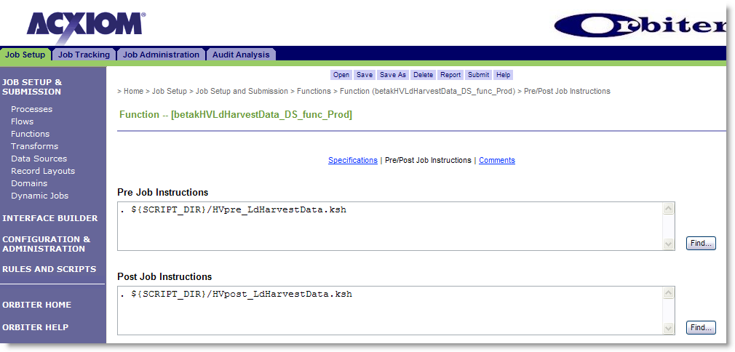
Figure 5. Job-Level Pre- and Post-Job Instructions
- Click Save to save your new Orbiter job.
NOTE: After you save your new Orbiter job, you need to create the Submit Options for the job. If you have not already done so, complete the procedure in Section 8 to create or modify Submit Options for the job before proceeding.
- Click Submit. You will be presented with a list of available submit options.
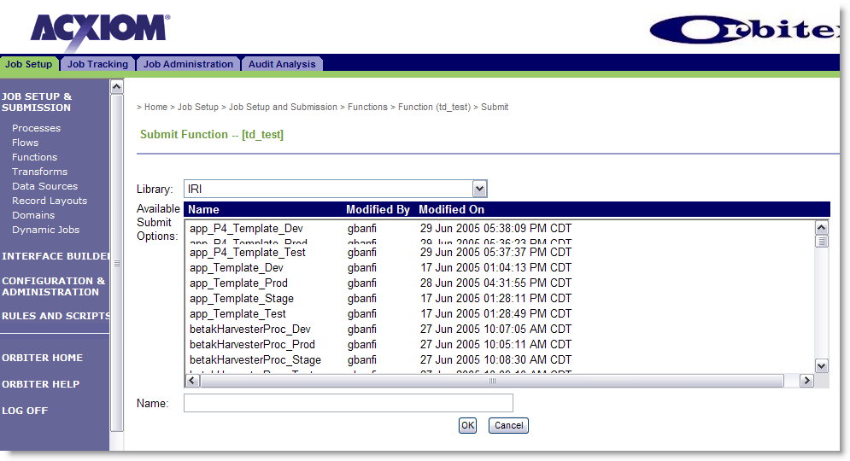
Figure 6. Submit Options
- Select the correct submit options file and click OK. The notification screen is displayed.
NOTE: Depending upon the access level set for the submit option, you may be able to modify the submit options at run-time.
- After you have verified or modified the submit options, click Submit to submit the job.
After you submit the job:
- Orbiter packages the job and all submit options into an XML document.
- The XML document is delivered to the Orbiter Submit Service (OSS).
- The OSS bundles the job with a run script that is sent to the Nexus scheduling and resource management utility. If any job errors have blocked the job from being submitted, OSS will log the status and send notification to the contacts identified in the submit options notification details.
- Nexus finds the requested nodes and runs the job.
A training presentation that describes this flow is provided on the Orbiter web site, at the link below:
http://orbiter.corp.acxiom.net/Documentation/Orbiter_Overview.ppt

Creating Submit Options
Once you have created a new job, you should set the submit options for the job. Submit options are parameters that are included with the job. This information includes notification information, along with other environmental parameters. Other things to note about submit options:
- Submit options can be created for a job or a process.
- There are submit option templates to use for each environment.
- Submit options are attached to the job or process at run-time.

To create a submit option:
- From the main Orbiter screen, click the Job Setup tab, then click Configuration and Administration.
- Click Submit Options.
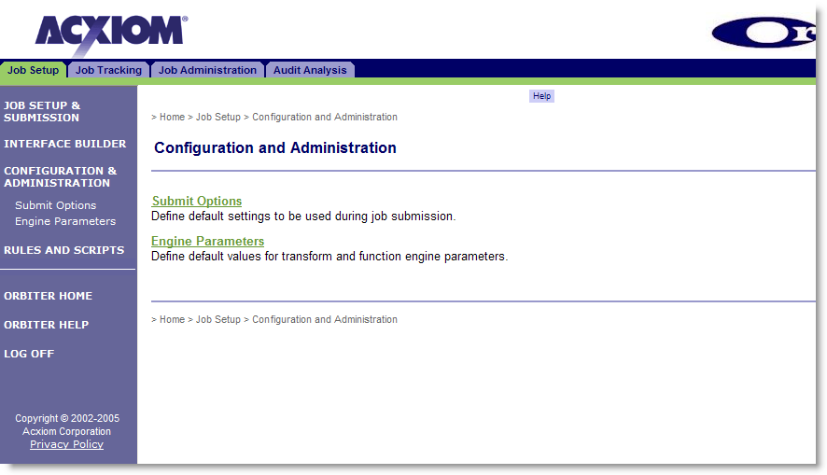
Figure 7. Configuration and Administration

- Click Open from the task options menu.
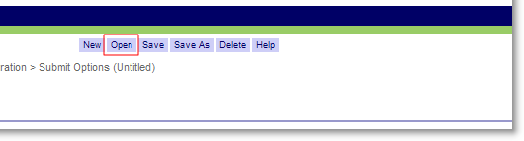
- Select one of the following submit options files from the list and click OK.
- app_Template_Dev
- app_Template_Stage
- app_Template_Test
- app_Template_Prod

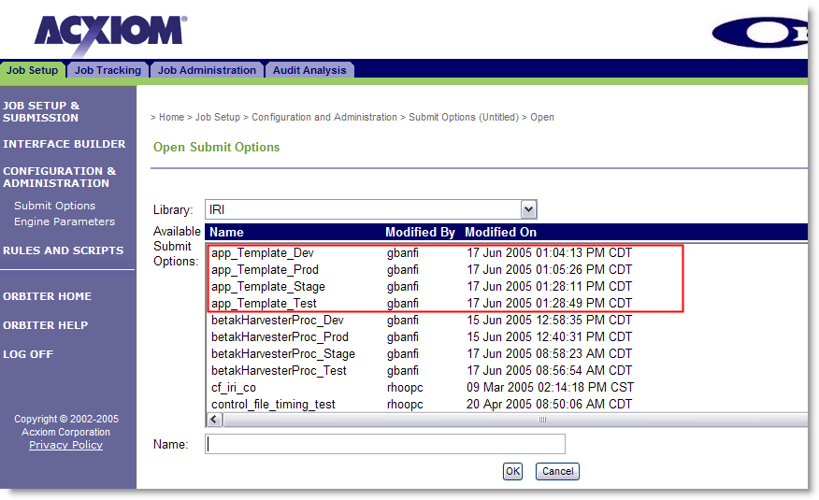
Figure 8. Submit Options Templates
- Click Save As (from the on-screen options menu) and save the submit options template file using a different name. Use the standard Orbiter naming convention for a submit options file.
- Complete the required and optional submission options.
- Under Required Submission Information:
- Job Submission E-mail Address. Use the default email address shown. As of the writing of this document, the default email address is: oss@orbiter2.conway.acxiom.com.
- Access Level at Submit Time. This option determines whether the submit options can be modified at submit time. Typically, you should select Show and allow modification for Development and Testing. For Production, you should either select Hide or Show.
NOTE: For each of the following options (except where noted), use the default option for Access Level at Submit Time. Typically, you should select Show and allow modification for Development and Testing and Hide or Show for Production.
- Under Optional Submission Information, click Edit to show the values for each of the following options.
- Server Groups. Verify that the server group is correct or enter the name of the server group where the job will be submitted. You may not need to change this option if you are using an existing submit options file for a job that is running successfully in the environment where the new job will run.
- Notification Settings. Verify that the notification settings are correct. From this screen, you can edit an email address, add a new contact's email address, or remove a contact. Select the Notification Points checkboxes for the job. An email notification to the contact(s) listed is sent by Orbiter when the selected job status occurs.
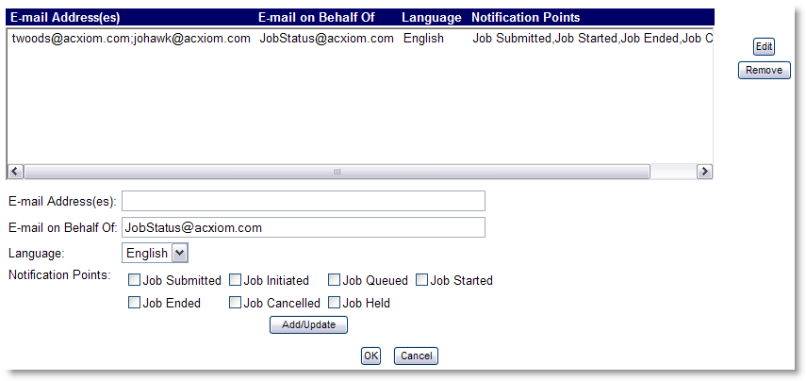
Figure 9. Notification Settings

- File Arrival Settings. Verify and modify the file arrival settings. You will need to identify the File Name/Pattern (mask) for the control file that will kick off the Orbiter job. For example:
/mnt/datagrid5/IRI/perm/blkbrd3/iriprod/data/
dataharvester/input/betakHarv*.ctl
A list of file arrival directories and file naming conventions is located in the following SharePoint location:
https://iriteams.infores.com/sites/regfactory/Org%20Process%20%20Logistics/Support%20Documentation/InboundFileDelivery.doc
Verify that the FTP Server Address and User ID are correct for the environment where the control file will land. Click Check FTP Logon to test the connection to the FTP server. Run One Time Only should remain unchecked, unless this is necessary for testing purposes.
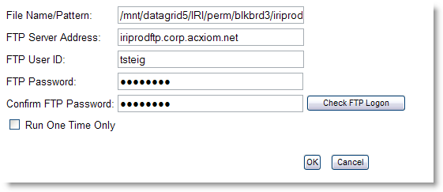
Figure 10. File Arrival Settings

- Scheduling Settings. As of the writing of this document, job scheduling is not used for the MK Gen 3.0-3.1 project.
- Cost Accounting Type. Use the default option Standard. Verify that the account information is correct. As of the writing of this document, the following are the correct values to use for the current MK project.
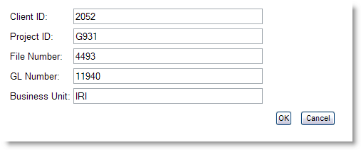
Figure 11. Cost Accounting Type
NOTE: For this option, you should select Hide for the access level at submit time.
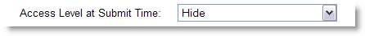

- Pre/Post Job Instructions. If you used a submit option template as the basis for your new submit option, leave the default entry for Pre Job Instructions as shown below.
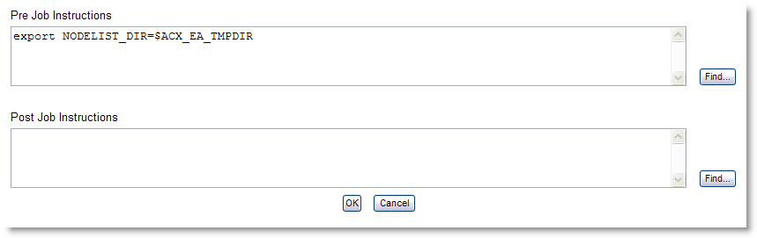
Figure 12. Engine-Level Pre- and Post-Job Instructions
NOTE: There are two types of pre and post job instructions: job-level instructions and engine-level instructions. The pre job instruction shown in Figure 12 is the default engine-level instruction in use for the MK project.
- Engine Parameters. Verify that the correct engine parameters file is being used for the job or process you are submitting. The Engine Parameters file contains the dynamic values for the job or process that apply the correct environmental parameters at job or process run-time.
Click Find to select a different engine parameters file from the library.
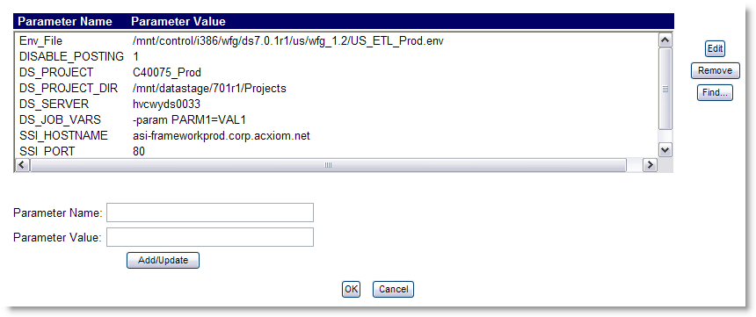
Figure 13. Engine Parameters
If you need to add or remove a parameter only for the specific job or process, you can complete this activity using this screen. However, if you are adding a parameter that could be used by another job or process, you should update the engine parameters file itself.
To add or modify an existing engine parameters file, go to Configuration and Administration > Engine Parameters.
NOTE: Engine parameters are created when a parameter needs to persist through the life of a specific Orbiter job flow. You create a new engine parameter if you need to overwrite a submit option parameter for a given job or if, through testing, you find that there is a new parameter that needs to persist for the complete job flow.
- Configuration File. Use the default setting for this option.
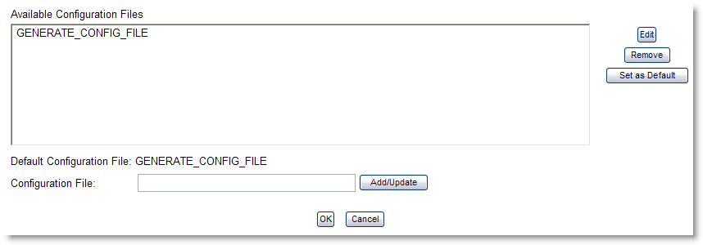
Figure 14. Configuration File

Once you have created a new Submit Options file and saved it to the Submit Options Library, you can use this file when submitting your job or process.

Creating a New Process
Many of the MK jobs that run on the workflow grid are linked together and run in a specific order. In the MK project, this is known as a Process. An MK process consists of multiple jobs that are linked to run in order. The following procedure provides you with the information necessary to create an MK Orbiter process.
NOTE: Before you begin, make sure you have created the jobs that will be used in your process flow and the submit options file that will be used at process run-time.
- From the Orbiter home page, go to Job Setup > Job Setup and Submission.
- Select Processes.
NOTE: The Functions selection is used to create a single job. If you need to create a single job, refer to Section 7.
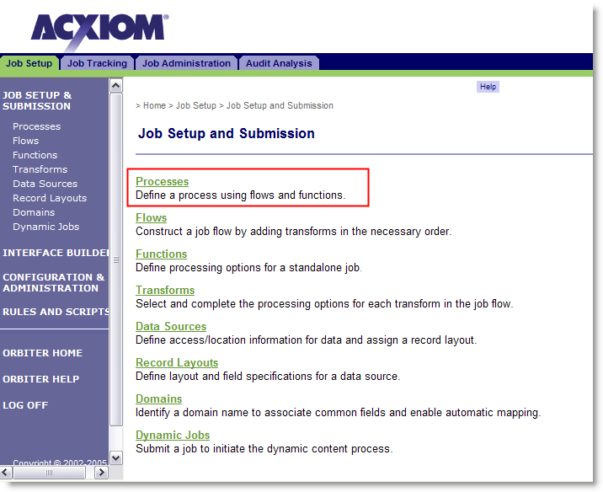
Figure 15. Job Setup and Submission
- The initial screen displayed is the Create Process screen. From this screen you select the jobs that run in the process.
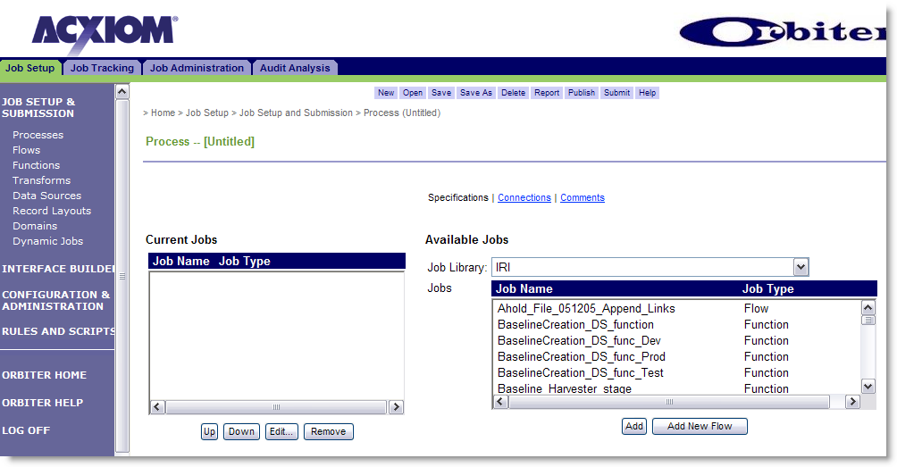
Figure 16. Create Process
- Select a job from Available Jobs and click Add. The selected job will be moved to the Current Jobs window and a process icon will be displayed in the lower portion of the screen. This is a graphical representation of your process flow.
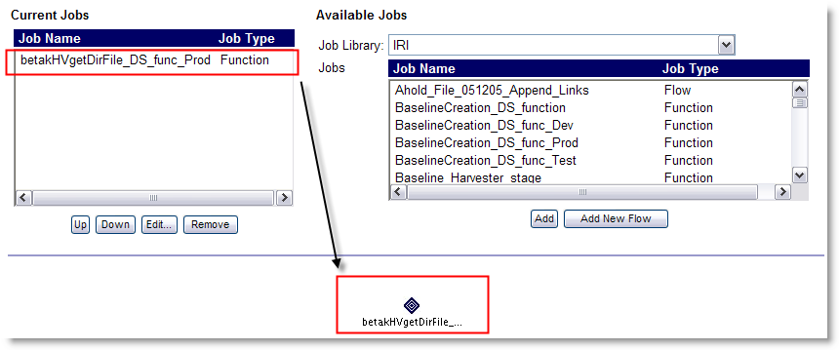
- Select each remaining job in your process flow. You can click Up or Down in the Current Jobs window to arrange them sequentially in the list. Note that the process flow is determined by the linked order of the icons in the graphical representation.
- Once you have added all the jobs to the list, click Connections.
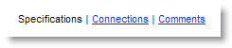
- Select the first job in your process flow from the Jobs on Process window.
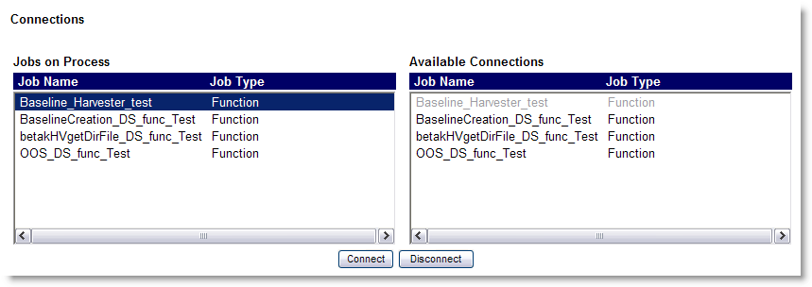
- Select the second job in your process flow from the Available Connections window.
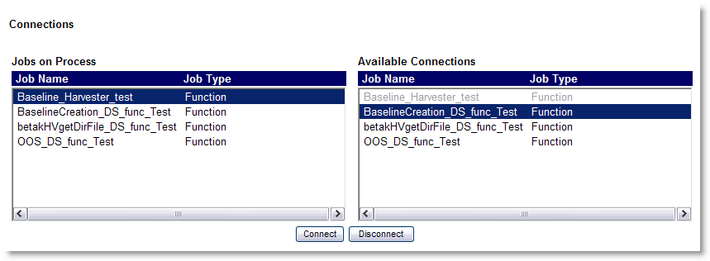
- Click Connect. The two icons are linked in the graphical representation of the process flow.
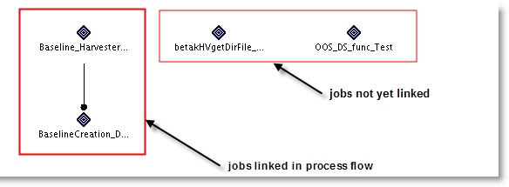
CAUTION: You can click an icon and open a specific Orbiter job to make changes to the job. If you change any of the information using this method, your changes are applicable only to the job in this process, not the job located in the library of jobs. If you make changes to the job in this process, you need to also duplicate the changes for the job in the library.
- Connect the remaining jobs to create your completed process.
- Once you have completed linking all the jobs in your process flow, click Save.
- After you have saved your process flow, click Submit. You are presented with the prompt shown below (as part of a selection screen).
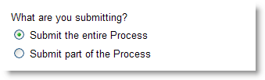
You can submit the entire process or submit part of the process. Typically, you submit part of the process when you are testing jobs and processes. After you have made your selection, you are presented with the list of available Submit Options.
- Select a submit options file for your process.
NOTE: If there is not an existing submit options file for you to use, or, you have not created a submit options file, refer Section 8, Creating Submit Options.
After you have selected the submit options file, the submit options screen is displayed.
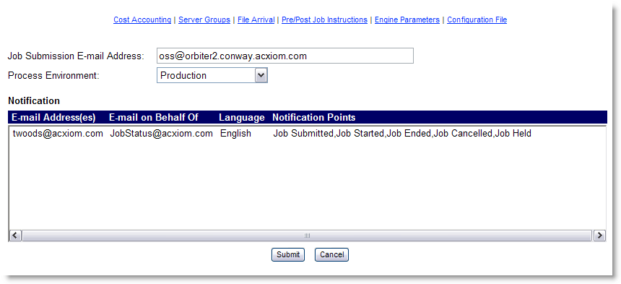
Figure 17. Submit Options Run-Time Edit
- Verify that the submit options are valid. If the submit options file was created with the correct access-level at submit time, you may be able to edit the submit options.
- Click Submit. Your process is submitted to the grid. You may view the job progress and details in the Nexus application.

Job Tracking
The following Orbiter features are available for tracking job status and for viewing the Orbiter job log.
NOTE: When completing any of the following procedures make sure that you wait for the information on the page to refresh before proceeding. You will see the following status message at the bottom of the screen when the site is busy updating.

Job Status
After you have submitted the job or process, you can track its progress using the Orbiter Tracking option. Use the following procedure to track a submitted job or process.
- From the Orbiter home page, click the Job Tracking tab.
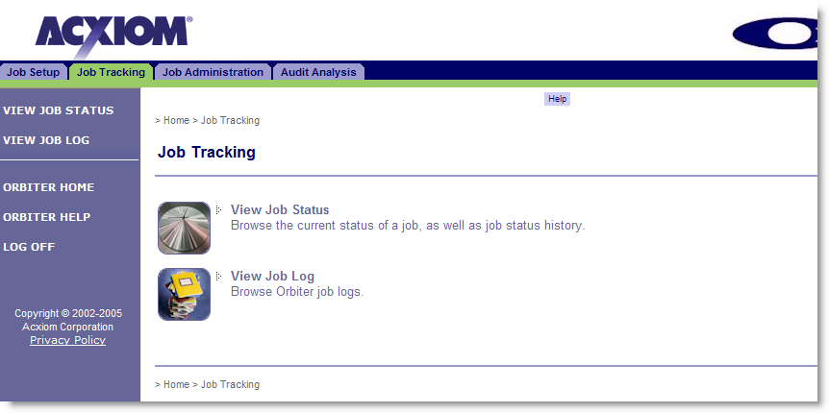
Figure 18. Job Tracking Tab
- Click View Job Status.
- On the Job Selection screen, you can leave the Status History and
Level of Detail to their default settings of Show and General, respectively.
- Get the job status by completing one or more of the following:
- Copy and paste an existing job number in the Job Number field and click View. After you click View, the screen updates with the job status and status history.
- Select the Job Name from the pull-down list of available jobs. When you select a job name, the screen updates with a drop-down list of available job numbers. Select the job number you want to view.
- Enter your job name in the Job Name field and click View. After you click View, the screen updates with a drop-down list of available job numbers. Select the job number you want to view.
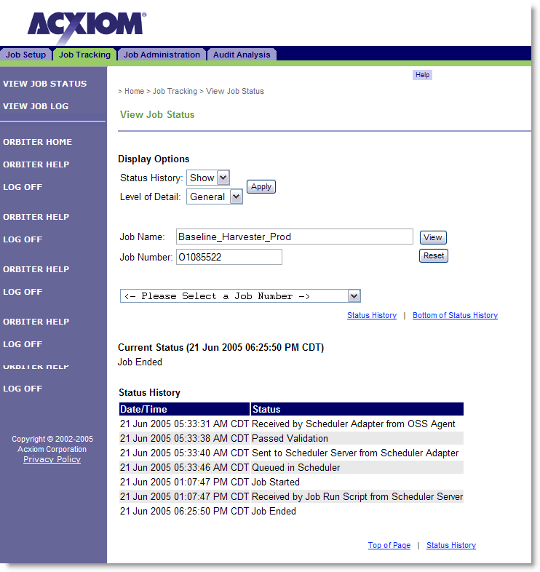
Figure 19. Job Status and Status History
- If you want to view additional information about the job status after it has been passed to the scheduler, go to Nexus. [will insert link to new Nexus section]

Job Log
To view the Orbiter log for a specific job, complete the following steps.
- From the Job Tracking tab, click View Job Log.
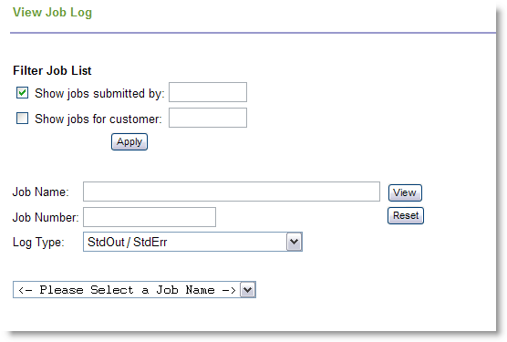
Figure 20. Job Log Selection
- Enter an Acxiom user ID in the Show jobs submitted by field to filter the search criteria to only those jobs submitted by the user ID you enter.
NOTE: For the MK project, you do not need to enter a customer ID. All MK project jobs are currently submitted for IRI.
- Select the Log Type you want to view. The default selection, StdOut/StdErr should be used, unless you are troubleshooting process issues.
- Complete one or more of the following to narrow the search criteria.
- Copy and paste an existing job number in the Job Number field and click View.
- Select the Job Name from the pull-down list of available jobs. When you select a job name, the screen updates with a drop-down list of available job numbers. Select the job number you want to view.
- Enter your job name in the Job Name field and click View. Select the job number from the drop-down menu and click View.
Once you have entered the job number and clicked View, the screen will refresh with the Orbiter job log for the selected job as shown in Figure 21.
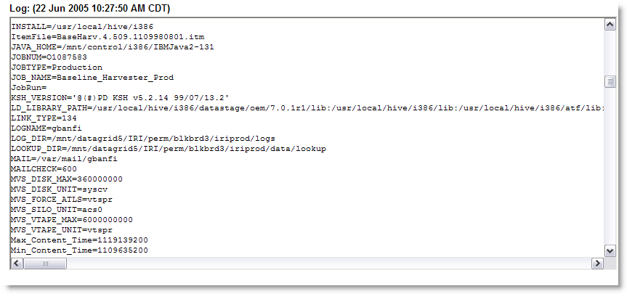
Figure 21. Job Log Example

